Unit7: Multimedia Design (4 Hrs.) Development Phases and Development Teams; Analysis, Design, Development and Implementation Phase; Evaluation and Testing Phase

Learning Objectives
After studying this chapter, students will be able to:
- Define Multimedia Design and explain its importance.
- Describe the Multimedia Development Life Cycle (MDLC).
- Explain the roles of Multimedia Development Teams.
- Understand each phase of multimedia development:
  - Analysis
  - Design
  - Development
  - Implementation
  - Evaluation and Testing
- Explain multimedia project management with practical examples.

Summary
Topic | Key Points
Multimedia Design | Planning and integrating multimedia elements into an interactive application
Development Team | Project manager, analyst, designers, programmers, QA, database developer, client
Analysis Phase | Gather requirements and assess feasibility
Design Phase | Create UI, storyboard, navigation, and database design
Development Phase | Build and integrate multimedia content and application code
Implementation Phase | Deploy the system, train users, and migrate data
Evaluation & Testing Phase | Verify functionality, usability, performance, compatibility, and security

Chapter: Multimedia Design (4 Hours)
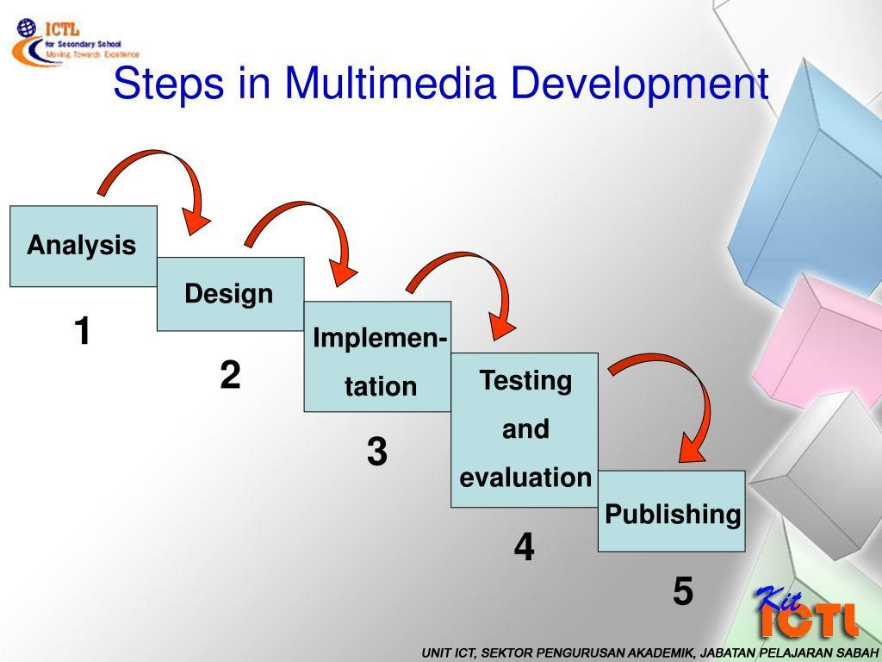

Phase | Activities | Output
Analysis | Gather requirements from users | Software Requirements Specification
Design | Create UI, storyboard, and navigation | Design documents
Development | Develop videos, quizzes, animations, and code | Working application
Implementation | Install system and train users | Operational LMS
Evaluation & Testing | Test features, usability, performance, and security | Approved final system
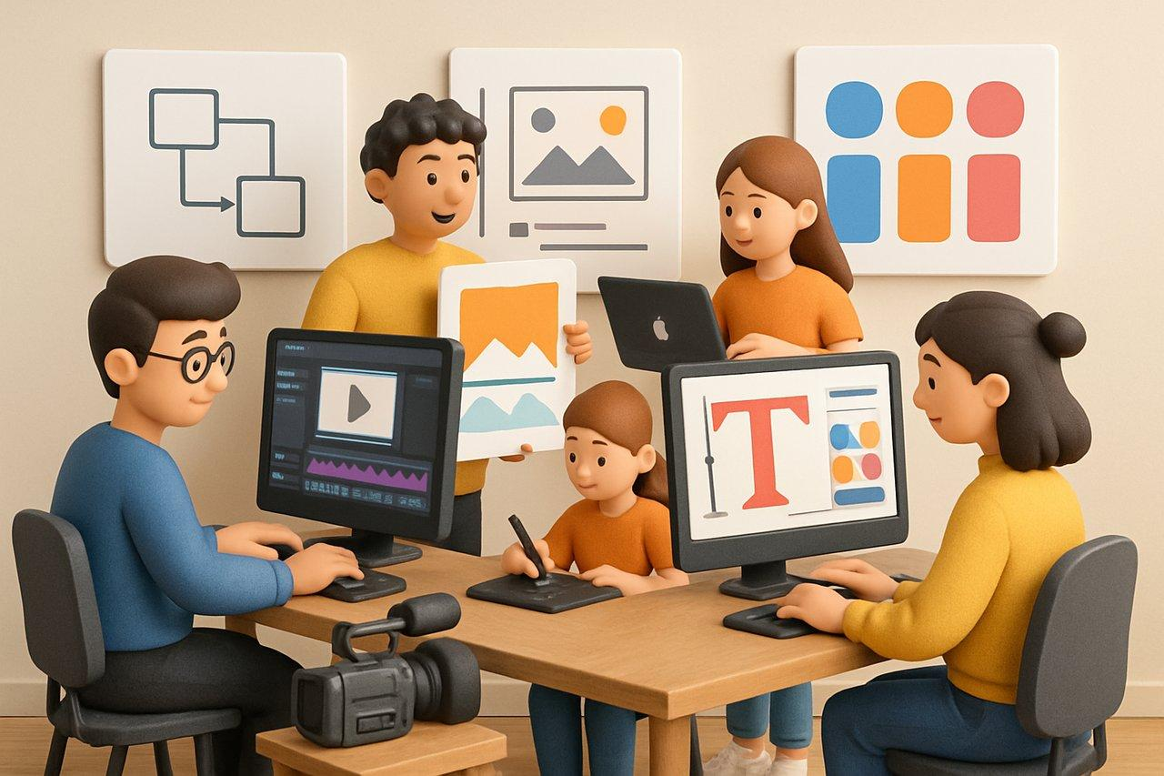
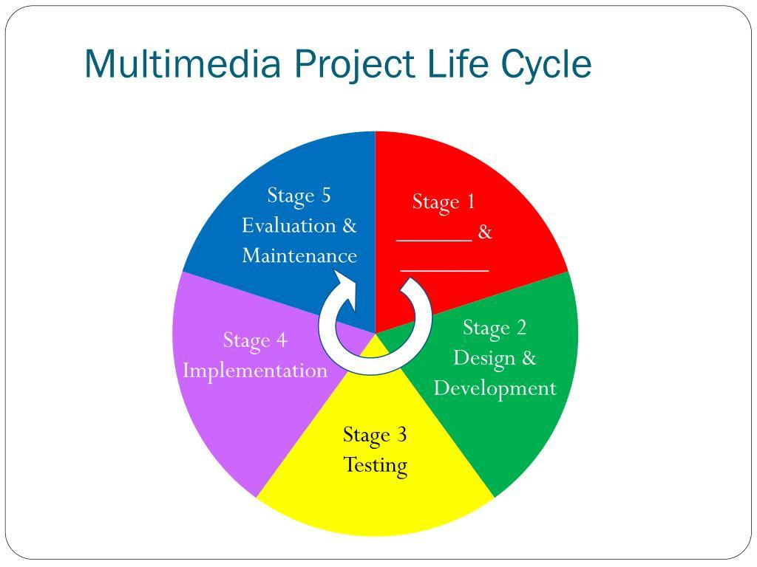
5

1. Introduction to Multimedia Design

What is Multimedia Design?
Multimedia Design is the process of planning, creating, organizing, and integrating different multimedia elements such as text, graphics, images, audio, video, animation, and interactive components into a single application to communicate information effectively.
It focuses not only on the appearance of the multimedia application but also on its usability, functionality, and user experience.

Definition
Multimedia Design is the systematic process of analyzing user requirements, designing interfaces, creating multimedia content, developing applications, testing functionality, and deploying interactive multimedia systems.

Example
A university develops an E-learning System.
The system contains:
- Text notes
- Images
- Audio lectures
- Video tutorials
- Animations
- Interactive quizzes
All these multimedia components are carefully designed and integrated to provide an engaging learning experience.

Characteristics of Multimedia Design
- Interactive
- User-friendly
- Attractive interface
- High usability
- Efficient navigation
- Responsive design
- Cross-platform compatibility

Objectives of Multimedia Design
- Present information effectively.
- Improve learning and understanding.
- Increase user engagement.
- Simplify complex information.
- Enhance user satisfaction.
- Support interaction between users and the system.

Importance of Multimedia Design
Importance | Description
Better Communication | Combines multiple media types for effective communication
Interactive Learning | Improves student engagement
Better User Experience | Creates attractive and intuitive interfaces
Marketing | Produces effective advertisements and presentations
Entertainment | Used in games, movies, and animations
Business | Supports training, demonstrations, and product visualization

Multimedia Development Life Cycle (MDLC)
The Multimedia Development Life Cycle consists of several structured phases.
Problem Identification
│
▼
Requirement Analysis
│
▼
System Design
│
▼
Development
│
▼
Implementation
│
▼
Evaluation & Testing
│
▼
Maintenance / Updates

Case Study: Development of an E-Learning System
MDLC Stage | Activities | Example Output
Analysis | Gather requirements from students and teachers | Software Requirements Specification (SRS)
Design | Create storyboards, UI layouts, navigation, and database schema | Prototype and design documents
Development | Build the LMS, integrate multimedia, write code | Functional e-learning application
Implementation | Install the LMS, migrate data, and train users | Live LMS for students and faculty
Evaluation & Testing | Perform functional, usability, performance, compatibility, security, and UAT testing | Tested and approved system
Maintenance | Fix bugs, improve features, update security, and add enhancements | Updated versions with improved functionality

Stage 1: Analysis Phase

Definition
The Analysis Phase is the first stage of MDLC. In this phase, developers identify the problem, understand user requirements, define project objectives, and determine whether the project is feasible.
This phase answers the question:
"What should the multimedia application do?"

Objectives
- Understand user needs.
- Define project scope.
- Identify target audience.
- Study existing systems.
- Assess feasibility.

Activities

Requirement Collection
Information is gathered through:
- Interviews
- Questionnaires
- Meetings
- Observation
- Document analysis

Audience Analysis
Questions include:
- Who will use the system?
- What is the users' age group?
- What language should be used?
- What devices will they use?
- What accessibility features are needed?

Feasibility Study
The project is evaluated for:
- Technical feasibility
- Economic feasibility
- Operational feasibility
- Schedule feasibility
- Legal feasibility

Deliverables
- Software Requirement Specification (SRS)
- Feasibility Report
- Project Scope
- Project Schedule

Example

Project: University E-Learning System
Requirements identified:
- Student login
- Video lectures
- Assignments
- Online quizzes
- Discussion forums
- Progress reports
These requirements are documented before moving to the next phase.

Stage 2: Design Phase

Definition
The Design Phase transforms the collected requirements into a detailed blueprint for the multimedia application.
It answers:
"How will the system work?"

Objectives
- Design the user interface.
- Plan system architecture.
- Design navigation.
- Prepare database structure.
- Plan multimedia elements.

Activities

Storyboard Design
The sequence of screens is sketched.
Example:
Home
│
▼
Login
│
▼
Dashboard
│
├── Videos
├── Assignments
├── Quiz
└── Results

User Interface (UI) Design
Design:
- Buttons
- Menus
- Icons
- Colors
- Fonts
- Layout

Navigation Design
Determine how users move through the application.
Example:
Home
│
├── Courses
│ │
│ └── Video
│
├── Quiz
│
└── Profile

Database Design
Create tables such as:
- Students
- Teachers
- Courses
- Videos
- Quiz Results

Deliverables
- Storyboards
- Wireframes
- UI Mockups
- Navigation Structure
- Database Design

Example
A prototype of the e-learning portal is created, showing the login page, dashboard, course pages, and quiz interface before coding begins.

Stage 3: Development Phase

Definition
The Development Phase is where the actual multimedia application is built according to the design.
This answers:
"How can we build the system?"

Activities

Multimedia Content Creation
Develop:
- Images
- Videos
- Audio
- Animations
- Graphics
- Text

Programming
Develop application modules.
Programming languages may include:
- Java
- Python
- C#
- PHP
- JavaScript

Multimedia Integration
Integrate:
- Images
- Videos
- Audio
- Animation
- Database
- User Interface

Database Development
Create:
- Tables
- Relationships
- Queries
- Reports

Deliverables
- Working software
- Source code
- Multimedia assets
- Database

Example
Developers create:
- Student registration page
- Video streaming module
- Quiz system
- Progress tracking dashboard
All components are integrated into one application.

Stage 4: Implementation Phase

Definition
The Implementation Phase is the stage where the completed multimedia application is deployed and made available to users.
It answers:
"How will users access the system?"

Activities

Software Installation
Install the application on:
- Computers
- Mobile devices
- Servers

User Training
Provide:
- User manuals
- Video tutorials
- Workshops
- Help documents

Data Migration
Transfer existing data into the new system.
Example:
Import student records from the old database into the new LMS.

Deployment
Launch the system for actual users.

Deliverables
- Installed application
- User manuals
- Training materials
- Operational system

Example
The university deploys the LMS on its server. Students receive usernames and passwords, and faculty members attend training sessions before the semester begins.

Stage 5: Evaluation and Testing Phase

Definition
The Evaluation and Testing Phase ensures that the multimedia application is functioning correctly, satisfies user requirements, and is ready for use.
It answers:
"Does the application work correctly?"

Objectives
- Identify defects.
- Improve quality.
- Verify requirements.
- Ensure user satisfaction.

Types of Testing

Functional Testing
Verifies all features work correctly.
Example:
- Login
- Video playback
- Quiz submission
- Report generation

Usability Testing
Checks whether the system is easy to use.
Questions include:
- Are menus easy to understand?
- Is navigation simple?
- Are buttons clearly visible?

Performance Testing
Measures:
- Response time
- Loading speed
- Server performance
- Scalability

Compatibility Testing
Checks compatibility with:
- Windows
- Linux
- Android
- iOS
- Chrome
- Firefox
- Edge

Security Testing
Tests:
- User authentication
- Password encryption
- Access control
- Protection against unauthorized access

User Acceptance Testing (UAT)
End users test the application before official release.

Deliverables
- Test Plan
- Test Cases
- Bug Reports
- Test Results
- User Feedback
- Final Approval

Example
Teachers and students test the LMS. They report that quizzes work correctly, but some videos load slowly. Developers optimize video compression and server settings before the final release.

Stage 6: Maintenance Phase

Definition
The Maintenance Phase begins after the system has been deployed. Its purpose is to keep the application functional, secure, and up to date.
It answers:
"How do we keep the system useful over time?"

Activities

Corrective Maintenance
Fix software bugs and errors.
Example:
Resolve a login issue reported by users.

Adaptive Maintenance
Modify the system to work with new technologies.
Example:
Update the application to support the latest Android version.

Perfective Maintenance
Improve existing features.
Example:
Add dark mode or improve dashboard performance.

Preventive Maintenance
Reduce the risk of future problems.
Example:
Update security patches and optimize the database.

Deliverables
- Updated software
- Bug fixes
- Performance improvements
- Security updates
- New features

Example
After one year, the university adds:
- Live virtual classrooms
- AI-based course recommendations
- Mobile notifications
- Faster search functionality
These enhancements are part of the maintenance phase.

2. Multimedia Development Phases and Development Teams
A multimedia project requires specialists from different fields working together.

Typical Multimedia Development Team
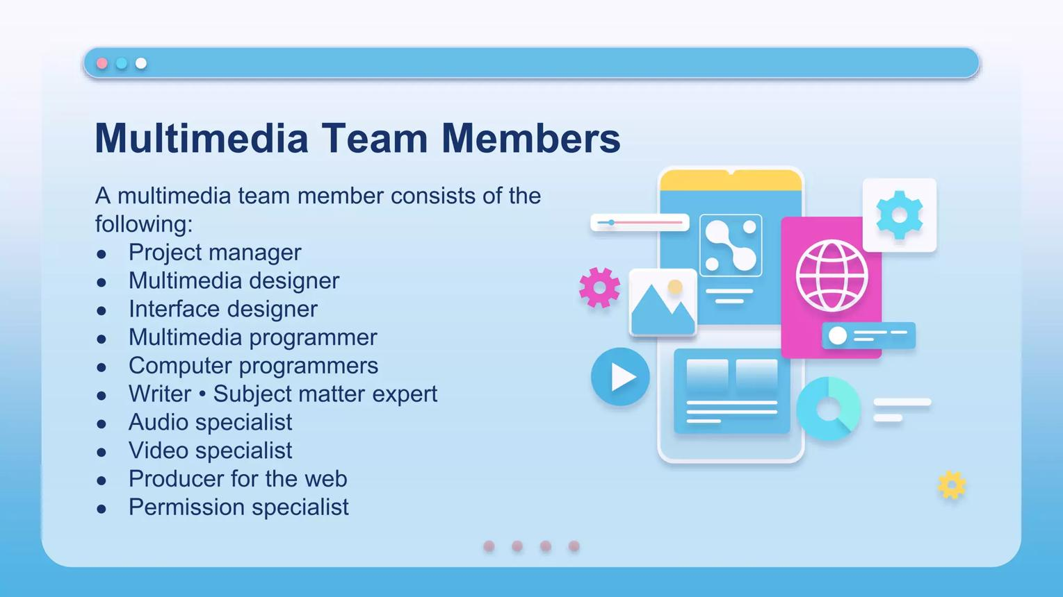
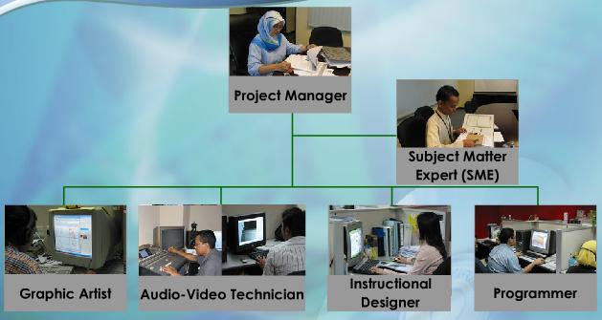
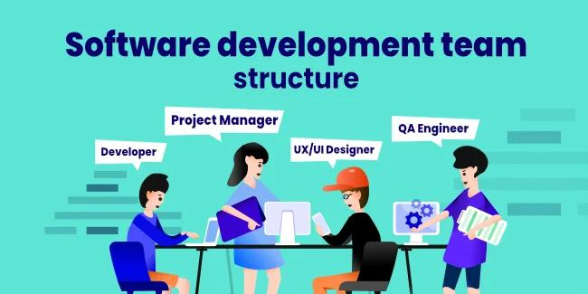
5
Project Manager
│
┌───────────────┼───────────────┐
▼ ▼ ▼
System Analyst Multimedia Designer UI/UX Designer
│ │ │
▼ ▼ ▼
Programmer Graphic Designer Animator
│ │ │
└───────────────┼───────────────┘
▼
Audio/Video Editor
│
▼
Database Developer
│
▼
Quality Assurance (QA)
│
▼
End Users / Clients

Roles of Development Team Members

1. Project Manager

Responsibilities
- Plans the project
- Allocates resources
- Manages budget
- Schedules activities
- Monitors progress
- Communicates with clients

Skills
- Leadership
- Communication
- Risk management
- Decision making

2. System Analyst

Responsibilities
- Collects user requirements
- Studies existing systems
- Prepares feasibility reports
- Creates system specifications

3. Multimedia Designer
Responsible for:
- Overall visual appearance
- Layout design
- Multimedia integration
- Navigation structure

4. Graphic Designer
Creates:
- Logos
- Icons
- Images
- Illustrations
- User interface graphics
Tools:
- Adobe Photoshop
- Adobe Illustrator
- CorelDRAW
- Canva

5. Animator
Creates:
- 2D animation
- 3D animation
- Motion graphics
- Character animation
Software:
- Adobe Animate
- Blender
- Maya

6. Audio and Video Specialist
Produces:
- Narration
- Music
- Video editing
- Sound effects
Tools:
- Audacity
- Adobe Audition
- Premiere Pro
- DaVinci Resolve

7. Programmer
Develops:
- Multimedia software
- Interactive applications
- Database connectivity
- User interaction
Languages:
- Java
- C#
- Python
- JavaScript
- PHP

8. Database Developer
Manages:
- User information
- Multimedia content
- Application data
- Security

9. Quality Assurance (QA) Engineer
Tests:
- Performance
- Functionality
- Compatibility
- Security
- Usability

10. Client / End User
Provides:
- Requirements
- Feedback
- Acceptance testing

3. Analysis Phase

Definition
The Analysis Phase is the first and one of the most important stages of multimedia development. During this phase, developers study the problem, understand user requirements, identify project goals, analyze available resources, and determine whether the project is technically and economically feasible.

Objectives
- Understand user needs.
- Identify target audience.
- Analyze existing systems.
- Define project scope.
- Conduct feasibility studies.

Activities

Requirement Gathering
Methods:
- Interviews
- Questionnaires
- Observation
- Document analysis

Audience Analysis
Questions include:
- Who will use the application?
- What is their age group?
- What language do they prefer?
- What devices will they use?

Feasibility Study
- Technical feasibility
- Economic feasibility
- Operational feasibility
- Schedule feasibility
- Legal feasibility

Deliverables
- Requirement Specification (SRS)
- Feasibility Report
- Project Plan

Example
A school wants an e-learning application.
Requirements include:
- Video lectures
- Online quizzes
- Student login
- Progress reports
These requirements are documented during the analysis phase.

4. Design Phase

Definition
The Design Phase converts the requirements collected during analysis into a detailed blueprint for the multimedia application.

Objectives
- Plan the application structure.
- Design interfaces.
- Organize multimedia elements.
- Define navigation.
- Prepare database design.

Activities

Storyboarding
Creates a visual sequence of screens.

Flowchart Design
Shows application logic.
Start
│
▼
Login
│
▼
Main Menu
├────Courses
├────Videos
├────Quiz
└────Exit

User Interface (UI) Design
Designs:
- Buttons
- Menus
- Icons
- Layout
- Colors
- Typography

Navigation Design
Defines movement between screens.
Example:
Home
│
├──Courses
│ │
│ └──Video
│
├──Quiz
│
└──Profile

Database Design
Defines:
- Tables
- Relationships
- Data storage

Deliverables
- Storyboards
- Wireframes
- UI mockups
- Navigation diagrams
- Database schema

5. Development Phase

Definition
The Development Phase is where the multimedia application is actually built according to the design.

Activities

Content Creation
Develop:
- Images
- Audio
- Video
- Animation
- Text

Programming
Write application code.
Example languages:
- Java
- Python
- JavaScript
- C#

Multimedia Integration
Combine:
- Images
- Videos
- Audio
- Database
- Animation

Database Development
Create:
- Tables
- Queries
- Relationships

Deliverables
- Working multimedia application
- Source code
- Multimedia assets
- Database

Example
An e-learning application now includes:
- Login page
- Video player
- Quiz module
- Student dashboard
- Database connectivity

6. Implementation Phase

Definition
The Implementation Phase is the process of deploying the completed multimedia application for real users.

Activities

Installation
Deploy software on:
- Computers
- Mobile devices
- Web servers

User Training
Provide:
- User manuals
- Training sessions
- Video tutorials

Data Migration
Transfer data from old systems to the new application.

System Deployment
Launch the application.
Example:
A university launches its Learning Management System (LMS) for students and teachers.

Deliverables
- Installed system
- User documentation
- Training materials

7. Evaluation and Testing Phase

Definition
The Evaluation and Testing Phase ensures that the multimedia application functions correctly, meets user requirements, and provides a high-quality user experience before and after deployment.

Objectives
- Detect errors.
- Improve quality.
- Verify requirements.
- Ensure user satisfaction.

Types of Testing

1. Functional Testing
Checks whether every feature works correctly.
Examples:
- Login
- Registration
- Quiz submission

2. Usability Testing
Evaluates:
- Ease of use
- Navigation
- User satisfaction

3. Performance Testing
Measures:
- Speed
- Response time
- Resource usage

4. Compatibility Testing
Checks operation on different:
- Browsers
- Operating systems
- Screen sizes
- Mobile devices

5. Security Testing
Tests:
- Authentication
- Authorization
- Data protection

6. User Acceptance Testing (UAT)
End users verify that the system meets their requirements before final acceptance.

Evaluation Criteria
Criterion | Purpose
Functionality | Verify required features
Usability | Ensure ease of use
Reliability | Check stable operation
Efficiency | Measure performance
Maintainability | Ease of updates
Portability | Ability to run on different platforms

Deliverables
- Test plan
- Test cases
- Bug reports
- Test results
- User feedback
- Final approval

Practical Example: Multimedia E-Learning System
Phase | Activities | Output
Analysis | Gather requirements from teachers and students | Software Requirements Specification
Design | Create UI, storyboard, and navigation | Design documents
Development | Develop videos, quizzes, animations, and code | Working application
Implementation | Install system and train users | Operational LMS
Evaluation & Testing | Test features, usability, performance, and security | Approved final system

Advantages of Following the Multimedia Development Process
- Reduces development risks.
- Improves software quality.
- Enhances teamwork and communication.
- Detects errors early.
- Improves user satisfaction.
- Simplifies future maintenance and upgrades.

